Load testing report

for Server-side of “Petstore” API

Test objective
- This testing was made to evaluate performance and stability of the “Petstore” API under different conditions and to find the Capacity threshold and long-term stability under load.

Test scope
- To be defined:
  - System performance under normal load (base data)
  - System peak performance threshold
  - System stability during endurance test
- Test scenario:
  - POST /pet – create pet
  - GET /pet/id – receive pet
  - PUT /pet – update existing pet
  - Delete /pet/id – delete created pet

Environment and preconditions to start:
- Endpoint to test: https://petstore.swagger.io/
- Tool: Apache JMeter

Load setups:
- Base:
  - Users: 20
  - Ramp-up: 2 minutes
  - Duration: 5 minutes
Active threads over time
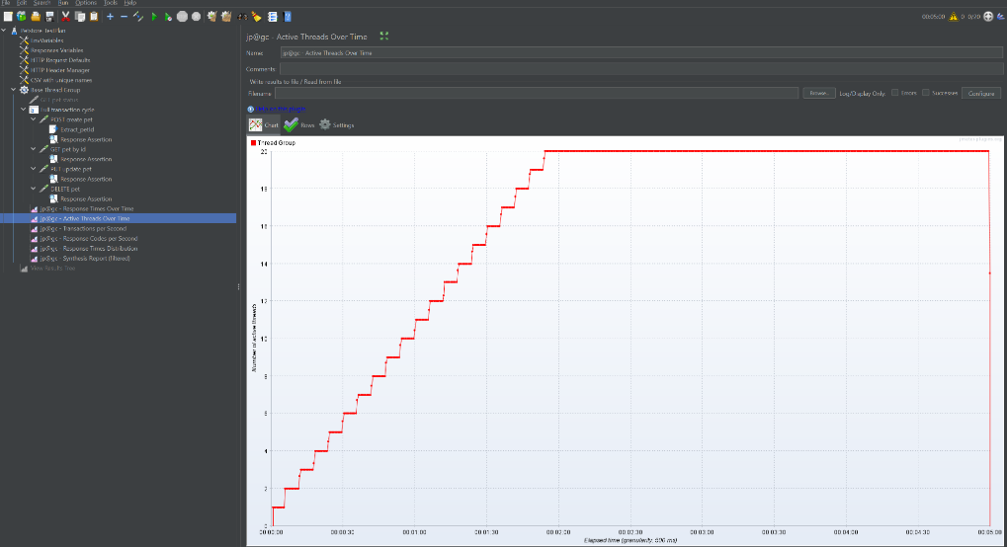

- Result:
  - Average Response Time: 472 ms
  - 90th Percentile: 481 ms
  - Error Rate: 0%
  - Throughput: 34 transactions/sec

- Stress test to define threshold:
  - Users: 200
  - Ramp-up: 2 minutes
  - Duration: 2 minutes

Response codes per second:
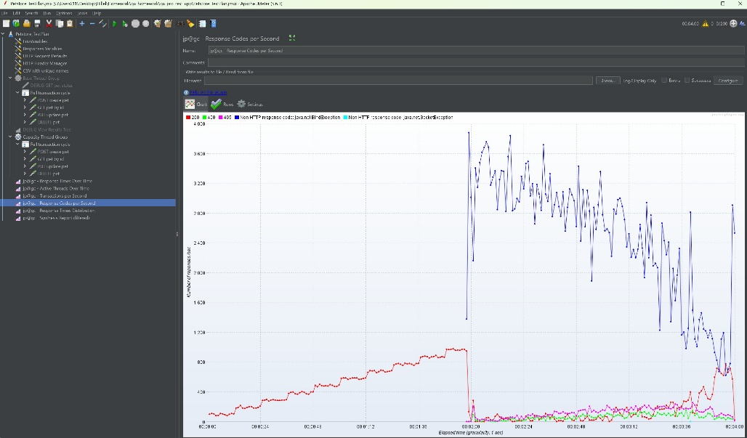
- Result:
  - Average Response Time: 344 ms
  - 90th Percentile: 827 ms
  - Error Rate: 80.5%
  - Throughput: 428 transactions/sec

- Endurance test:
  - Users: 20
  - Ramp-up: 2 minutes
  - Duration: ~15 minutes
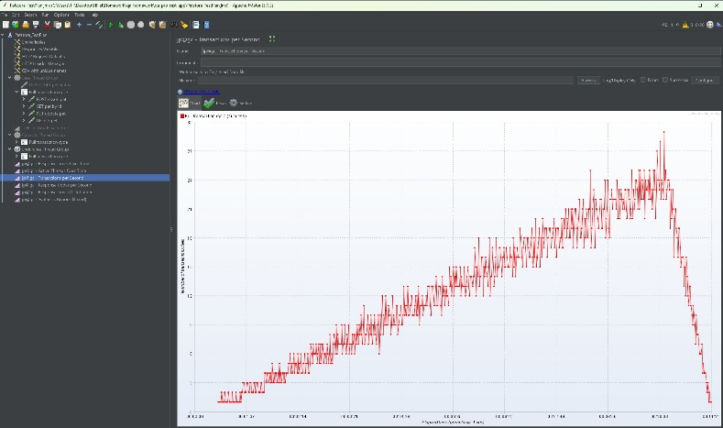
- Result:
  - Average Response Time: 821 ms
  - 90th Percentile: 840 ms
  - Error Rate: 0%
  - Throughput: 12 transactions/sec

Performance analysis:
- Base scenario shows stable work under mid load
- Stress scenario shows that system threshold ~200 users. After it was achieved:
  - Error rate increased
  - System stability isn’t checkable
- Endurance scenario confirms that with stable range of users, system isn’t stuck
All reports are saved in the “Resources”

- Conclusions:
- “Petsore” API operates stable under load of 20 concurrent users
- Stress threshold = 200 users
- Under stress test system react with overload and error responses
- Under endurance test system react with stable behavior
- It is recommended to increase maximum of the simultaneous users to be able to operate the app

